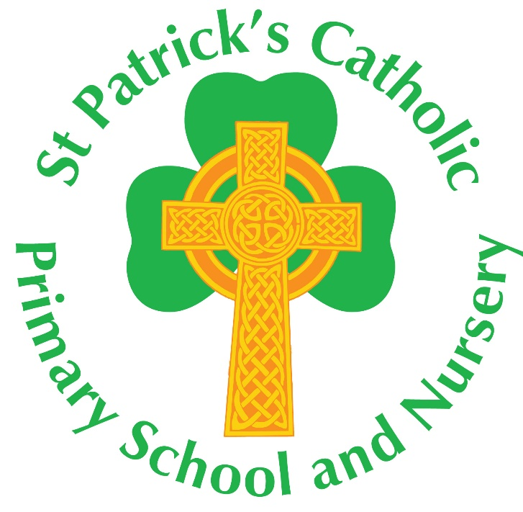

R.E. Policy
(No 82)

Responsibility for policy update lies with the R.E. Subject Leader | Dates Adopted
 | 19.06.14
 | 25.01.18
To be reviewed by Curriculum Committee a minimum of every Annually. | 07.07.21
 | 06.07.23
 | 02.07.24

Mission Statement
‘Christ be with me and Christ be within me.’

Introduction
Our school is a place where the Spirit of Christ lives. We seek to ensure that the message and spirit of the Gospel permeates all aspects of school life. All children are welcomed and each one nurtured in a union of support between school and parish so each may reach their full potential. We celebrate the uniqueness of the individual and believe each child is created in the image and likeness of God. Our school is a community of faith, in which each member participates fully, and R.E. is where that faith seeks wisdom, understanding and knowledge.

Rationale of Religious Education
Religious Education is central to the educative mission of the Church.
‘At the heart of Catholic education lies the Christian vision of the human person. This vision is expressed and explored in Religious Education.’
- Religious Education is ‘the core of the core curriculum.’
‘Therefore Religious Education is never simply one subject among many, but the foundation of the entire educational process. The beliefs and values studied in Catholic religious education inspire and draw together every aspect of the life of a Catholic school….. All pupils have the right to receive an overall education which will enable them, in the light of the faith of the Church, to engage with the deepest questions of life and find reasons for the hope which is within them. Religious Education is, then, the core subject in a Catholic school.’1
- Religious Education is the systematic study of the teaching of the Church and the mystery of Christ and is a rigorous academic subject in its own right.
Religious Education is regarded as an academic discipline with the same systematic demands and the same rigour as other disciplines. 2 As such it is to be taught, developed and resourced with the same commitment as any other subject.
“Excellence in religious education, then, will be characterised by a clarity of succinct religious learning objectives and of key content, by appropriate methodologies, rigour, richness of resources, achievement of identified outcomes and accurate methods of assessment. Classroom RE will be a challenging educational engagement between the pupil, the teacher and the authentic subject material.” 3

- Whilst evangelisation and catechesis are happening in our school for some pupils, the specific contribution Religious Education makes to the Catholic Life of the school is primarily educational and will be planned, taught, assessed and monitored with the same rigour as other curriculum subjects.
- The outcome of Classroom Religious Education is:
“religiously literate and engaged young people who have the knowledge, understanding and skills – appropriate to their age and capacity – to reflect spiritually, and think ethically and theologically, and who are aware of the demands of religious commitment in everyday life”.4

Aims
The Aims of Religious Education in St Patrick’s Catholic Primary School will include the following:
- To create a safe, secure and stimulating learning environment for all.
- To deepen the children’s knowledge and understanding of our Catholic faith through following the Bishops Conference approved scheme ‘Day by Day’ which is written by the Diocese of Arundel and Brighton, in conjunction with St Mary’s College Twickenham, and supports the delivery of the RED ‘To Know You More Clearly.’
- To deepen the children’s knowledge and understanding of our Catholic faith through prayer and the Gospels.
- To foster pupils’ awareness that our Christian faith is not just a subject for learning but a complete way of life.
- To promote the spiritual and moral development of all children.
- To help pupils develop positive attitudes towards people of other faiths, showing respect and understanding within the multi-cultural society in which we live.
- To enable a deepening knowledge and love of Christ within the Sacraments of the Church.
- To reflect the liturgical year in the life and activities of the school.
- To ensure strong links are made across other curriculum areas.
- To involve parents/carers in all aspects of school life.
- To incorporate the Pupil voice into the ongoing development of R.E.

The Religious Education Programme
At St Patrick’s School we follow the Catholic Primary Religious Education Programme ‘Day by Day’ which supports the delivery of the RED ‘To Know You More Clearly.’ Its implementation is supported by ongoing staff training, a variety of appropriate resources and support from NORES.

Methodology
A variety of teaching and learning strategies will be used from across the curriculum adapted appropriately to the needs and learning styles of pupils.

Time Allocation - Curriculum
R.E. is allocated 10% of curriculum time as required by the Bishops Conference. As in all our teaching, we approach Religious Education by first and foremost recognising the age and maturity of the child. The starting point is the pupil’s own experience, and the task of the teacher is to develop, deepen and widen the child’s perception. A balance is sought between various teaching methods so that group discussions, art, drama and role play, godly play and question and answer session will all have a part to play to develop skills in R.E, as well as growing knowledge of our Faith. This does not include Collective Worship.

Inclusion and Equality
All pupils in our school, irrespective of ability, faith and background will have appropriate differentiated access to the Religious Education programme.
The governing body have wider responsibilities under the Equalities Act 2010 and will ensure that our school strives to do the best for all of the pupils, irrespective of disability, educational needs, race, nationality, ethnic or national origin, sex, gender identity, religion or sexual orientation or whether they are looked after children. Policies and procedures are in place for accessibility and disability.
Staffing and Responsibilities
The R.E Subject Leader has responsibility for leading, managing and supporting the delivery of, and training in, Religious Education.
The R.E. Subject Leader will:
- Ensure the high profile of R.E. at all times.
- Support staff in the teaching, assessing and evaluating of R.E. within the school.
- Attend the R.E Subject Leader’s Meetings and all relevant training through NORES, reporting back to colleagues any relevant information.
- Lead staff meetings where R.E. is the theme.
- Promote and monitor the curriculum throughout the school.
- Develop and maintain a bank of resources to support teaching and learning in R.E.
- Ensure that sacramental programmes, led by the Parish, are supported for children in Year 3 and Year 6.
- Ensure that each term parents receive information on the topics to be covered in R.E. (Class Newsletters)

Each Class Teacher
- Prepares, plans and delivers the R.E Curriculum to their respective classes.
- Helps children to develop their knowledge of God and their relationship with Him through scripture, prayer and reflection.
- Provides regular prayer opportunities.
- Creates interesting and stimulating R.E. displays in their classrooms.
- Introduces children to the Liturgical Feasts and Seasons of the Church

Resources
The R.E. cupboard contains a range of resources which are targeted to each key stage but stored together so that everyone can access and make best use of what we have. All children have access to Bibles and staff have their own copy of the curriculum strategy related to their year group.
Each class is supported with a Liturgy Box, wherein class prayers, seasonal drapes, and various symbolic items are kept to enable prayer tables to reflect the colours of the Liturgical Year and collective acts of worship to be relevant.
An annual R.E. budget allows for the purchase of new and engaging resources as well as the upkeep/replenishment of existing equipment.

Special Needs
We enable all pupils to have access to the full range of activities involved in R.E. Teachers plan differentiated work for their pupils in R.E. as in other curriculum subjects.
Differentiation is achieved by:
a) Additional resources provided by the teacher to help the child.
b) A more appropriate task set by the teacher.
c) A less demanding outcome expected of the child.
d) Additional support by the teacher or classroom assistant for the child to carry out the task.

Assessment

The purpose of assessment in R.E. is not an assessment of a child’s relationship with Almighty God or the practice of their faith, but an assessment of the child’s knowledge and understanding that is required, as they develop a full relationship with God
- Moderation of pupil’s books is undertaken by the R.E. leader and as a whole school in -line with our moderation timetable.
- A range of pupils’ books are presented for Diocesan Moderation at RE Coordinators’ Moderation meetings (usually in the summer term) as per the timetable of our cluster.
- Monitoring of teaching and learning is undertaken by the R.E. Subject Leader and other school/diocesan leaders as per our monitoring timetable.
- Progress in Religious Education is reported to parents/carers in a written report at the end of each academic year.
- Progress and achievement in Religious Education is reported to Governors annually.
- More formal assessment is currently under development for the new RED and will be implemented when it is available to us.

Spiritual Development
A) Worship

(i) A collective act of worship takes place daily in the School.

Our Assembly rota is as follows:-
Monday – Gospel Assembly
Thursday – Rejoice and Sing
Friday – Celebration Assembly
On a Tuesday, a Wednesday and a Thursday, acts of collective worship take place in the classroom and are supported through Ten:Ten Resources or to a relevant date or event in our Liturgical year i.e. feast days.

B) Prayer

Children are taught daily prayers and also the various prayers and responses of the Mass, as appropriate to their age and stage of development. Each classroom has a focal point for prayer and children pray together with their teacher at various times throughout the day.

We strive to provide quality experiences of prayer and liturgy that support the children’s spiritual development and add personal depth to their learning,

As a staff we pray together at the beginning of every staff meeting.

Links with Parents and the Parish Community

Parents are invited to many celebrations throughout the year including: All school Masses, End of Term Celebration Assemblies, Harvest Festival, Carol Concert, Christmas Shows and the Easter Performance. Headteacher newsletters and class newsletters are sent home termly (6 times per year).

Preparation for the Sacraments

Preparations for receiving the Sacraments of Reconciliation, Eucharist and Confirmation are all now undertaken by the Parish, in line with diocesan recommendations. Pupils in Year 3 and Year 6 are supported with this through regular communication between home, school and parish and through our school hall being made available for town-wide sacramental preparation classes on Saturday mornings (as per the timetable of the parish).

Multi-Cultural Development

The Religious Education programme is supported across many areas of the curriculum. Children are exposed to the teachings and knowledge of all the great world religions and pupils are taught to respect people of different and no faith traditions. Our teaching of other faiths is outlined in the new RED

Visitors to school provide the children with an insight into world cultures through dance, story, drama and food!

The Legal Position

Our school curriculum for RE meets the requirements of the 1988 Education Reform Act (ERA). The ERA stipulates that religious education is compulsory for all children, including those in the reception class who are less than five years old. The ERA allows parents and carers to withdraw their child from religious education classes if they so wish, although only after they have given written notice to the school governors. Withdrawing a child from R.E. also means withdrawing them from all assemblies as they include a collective act of worship and from the Easter and Christmas performances. Further information can be accessed from NORES and the CES regarding our legal position.

Family Life – Relationships and Sex Education

To enable a holistic growth of the children’s understanding of human relationships we follow the ‘Life to the Full’ programme devised specifically for use in Catholic primary schools. Please see our RSHE Policy for further information.

Religious Education in Catholic Schools, Bishops’ Conference of England and Wales, 2000, para 4 2 Religious Education Curriculum Directory, Department of Catholic Education and Formation, Bishops’ Conference of England and Wales, 2012, p.3 3 Religious Education in Catholic Schools, Bishops’ Conference of England and Wales, 2000, para 7 4 Religious Education Curriculum Directory, Department of Catholic Education and Formation, Bishops’ Conference of England and Wales, 2012, p.6

